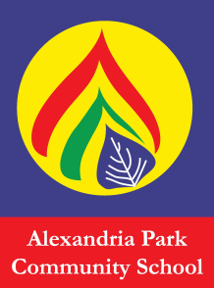
Dear Parents/Guardians,

Alexandria Park Community School Homework Centre will resume on Wednesday (26/4/2017) afternoon between 3pm – 5pm in the Library. There will be a fee of $2 per session to cover afternoon tea for the children. Fees for Yr3-6 can be paid termly.
All year 3-12 students are welcome to come along and do their homework, assignments or in class catch up work. If your child wishes to attend the homework centre, please complete the registration slip below and return it without payment to the school librarian during 1st-2nd week of each term.

………..……………………………………………………..…………………
APCS Homework Centre
I give my child ____________________________ [student name] of class _________ permission to attend APCS Homework Centre on Wednesdays from 3pm -5pm.
I will pick up my child from the centre or arrange own transport home at no later than 5pm.
Please choose 1 of the following transport options.
Parent will pick up

Student will leave centre and arrange own transport home.

Parent/Guardian name: (print)______________________
Parent/Guardian signature:________________________
Mobile number: _________________________________

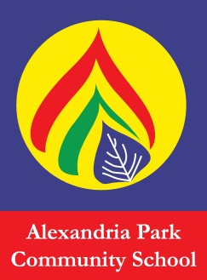
Homework Club Food Permission

I give permission for my child: __________________________________________________ in class/year __________ to eat Nutella at Homework Club.
Yes or No (please circle)

My child does have reactions to certain food products : Yes or No (please circle)
My child is allergic to or has reactions to the following: (please list)

Example of some of the other food types we will be proving during the term are: Fairy Bread, toasted Cheese sandwiches, Popcorn, Muffins, Lamingtons, Pancakes, Fruit, Cordial drinks (red, green, orange, lemon, raspberry), Biscuits, Crackers, Vegemite, Honey etc.

Please choose fee options below. A letter will be sent to you via your child for payment at beginning of each term.

$10 for Term 1 $20 for Term 3

$20 for Term 2 $20 for term 4

Thank you.

