Alexandria Park Community School – ‘Bring Your Own Device’ Policy

Rationale
Technology plays a large role in our students’ lives and personal devices can enhance and enrich learning opportunities both at school and at home. Alexandria Park Community School is committed to allowing responsible, learning-centred use of personal devices at school so as to provide as many pathways to understanding as possible for our students. All students are required to bring their own computing device to school each day.

What types of Devices students can bring to school?
A range of devices in a range of price categories will meet the APCS Device Specifications. Ideally, we recommend a laptop, as these have the capacity to support all the functionality we require in terms of storage, capability and typing. You may already have a device at home that meets the specifications. Students are encouraged to bring a computing device that they are familiar with using.
iPads are acceptable and we encourage students to pair these with compatible keyboards. We do not recommend the use of generic tablets as these cannot support the majority of the software and apps we require students to use.
There is no need to purchase any software, as the software that is required can be downloaded for free as part of the Department of Education’s Enterprise Agreements.

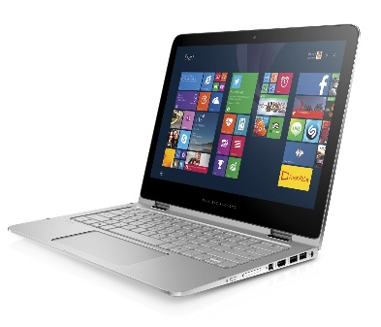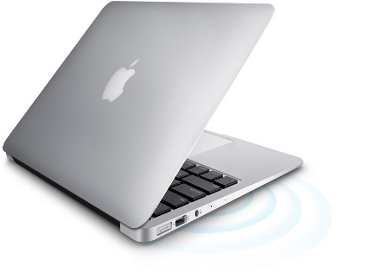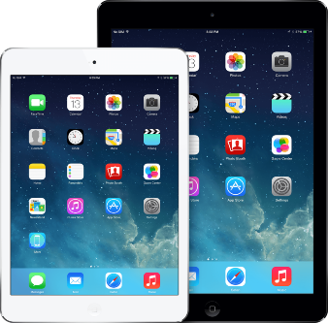

Smartphones are not considered an acceptable learning device.
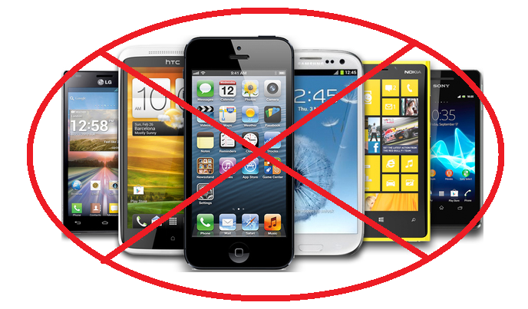

What are the BYOD Device Specifications?
Specification | Details
Wireless Connectivity  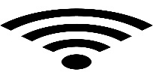 | Wireless connectivity (Wi-Fi enabled) is the key element to BYOD devices in schools!  The Department’s Wi-Fi network operates on the 802.11n 5Ghz Standard. Devices that do not support this standard will not be able to connect at school.
Battery Life  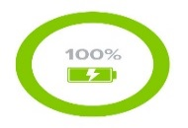 | Devices must have a minimum 5 hours battery life when fully (100%) charged.  Students must remember that using devices outside of class time reduces battery life.
Memory and RAM  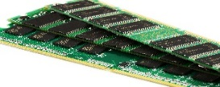 | Devices must have a minimum 16GB storage and 4GB RAM.  To be able to store and process data effectively these minimum specifications are recommended.
Hardware Features  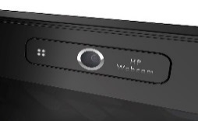 | Devices must have a Camera and a Microphone.  These are necessary to ensure students can participate in 21st Century learning activities.  Keyboards for tablets are strongly recommended.
Screen Size | Ensure the screen size is of a reasonable size to enable ease of use throughout a school day. As a minimum they should be 300mm (12”) diagonally.
Casing  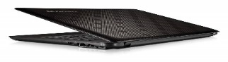 | Casing needs to be tough and sturdy to reduce the chance of damage.
Weight | The device needs to be light enough to be carried comfortably each day in addition to other learning materials (books, pencil case etc.).
Durability  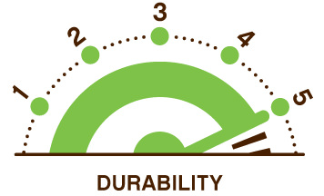 | The device must have sturdy keys and inputs that can withstand everyday ‘wear and tear’.
Carry Case  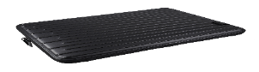 | The carry case is essential for protection and reduces the risk of damaged casing and cracked screens.
Other Key Considerations:
Insurance – Devices can become lost or be broken easily at school. Make sure your household insurance policy covers these eventualities or arrange alternative insurance.
Warranty – Make sure you consider purchasing extra warranty to reduce future repair costs as these devices will be used extensively.

The Responsibilities of the School
Alexandria Park Community School expects that each staff member will aim to incorporate appropriate use of electronic information throughout the curriculum (as they would any other curriculum resource) and that teachers will provide guidance and instructions to students in the appropriate use of such resources. Staff will facilitate student access to curriculum information resources appropriate to the individual student’s instructional needs, learning styles, abilities and developmental needs.

Responsibilities of Teachers
- Teachers will encourage and facilitate the use of personal devices. Students must use these devices as directed by their teacher.
- Teachers should follow the school’s discipline procedures if a student uses their device inappropriately.

Alexandria Park Community School will NOT be responsible for:
- personal devices that are broken/damaged while at school or during school-related activities
- personal devices that are lost or stolen at school or during school-related activities
- maintenance or upkeep of any personal device (keeping it charged, installing updates or upgrades, fixing any software or hardware issues).

The Responsibilities of the Students
Students are responsible for safe, respectful, learning and behaviour on the school computer network as detailed in the school’s Student Management and Behaviour Policy. Individual users of the school computer networks are responsible for their behaviour and communications over those networks, it is presumed that students will comply with school standards and will honour the agreement they have signed.

Students’ Responsibilities:
- The personal device must be able to be brought to school every school day and be used solely by the student throughout the school day.
- Students are responsible for making sure their device is charged at home and ready for each class.
- Students bring their own device for use at Alexandria Park Community School at their own risk. They are responsible for all repairs and support concerning their device.
- Students and parents/carers are responsible for ensuring the device brought to school meets all the requirements of the Device Specifications.
- Prior to bringing a personal device for the first time, students and their parents must read and sign the APCS Computer Access and BYOD User Agreement which sets out the responsibilities and expectations for use of the personal device at Alexandria Park Community School.
- Students must follow teachers’ directions as to appropriate use of their devices in class.
- Each student is absolutely and solely responsible for the care and conduct of their own personal device.

Expectations of Use
- Use of personal laptop or tablet devices during the school day is at the discretion of the teachers and staff. Students must use these devices as directed by their teacher. The primary purpose of the use of personal devices at school is educational. While at school, all material on school computers and personal devices is subject to review by school staff.
- The use of a personal device is not to be a distraction in any way to teachers and students. The use of personal devices must not disrupt the class in any way.
- Students are to connect their device to the designated wireless network only. Students are not to connect their device to other wired, wireless or cellular networks whilst at school.

Consequences for Misuse of Equipment
- Standard school discipline procedures apply for misuse of the device contrary to this policy.
- Examples of action the school may take in cases of misuse include:
- Permission for the student to bring their device to school pursuant to the Bring Your Own Device policy is revoked
- Conventional discipline procedures including detention or suspension where deemed appropriate pursuant to the school’s discipline procedures.

The Responsibilities of Parents
Parents and guardians are ultimately responsible for setting the standards that their children should follow when using media and information sources, and ensuring that these standards are met.

- Parents are responsible for all repairs and support concerning their child’s device.
- Parents are responsible for ensuring the device brought to school meets all the requirements of the Device Specifications.
- Prior to bringing a personal device for the first time, students and their parents must read and sign the APSC BYOD User Agreement which sets out the responsibilities and expectations for use of the personal device at Alexandria Park Community School.
- Insurance: Alexandria Park Community School recommends that all personal devices be covered by personal insurance and that policies include specific accidental loss and breakage insurance.
- Warranty: Make sure you consider purchasing extra warranty to reduce future repair costs as these devices will be used extensively.

Privacy and Confidentiality
Students will:
- never publish or disclose the email address of a staff member or student without that person's explicit permission.
- not reveal personal information including names, addresses, photographs, credit card details and telephone numbers of themselves or others.
- ensure privacy and confidentiality is maintained by not disclosing or using any information in a way that is contrary to any individual’s interests.

Intellectual Property and Copyright
Students will:
- never plagiarise information and will observe appropriate copyright clearance, including acknowledging the author or source of any information used.
- ensure that permission is gained before electronically publishing users’ works or drawings. Always acknowledge the creator or author of any material published.
- ensure any material published on the internet or intranet has the approval of the principal or their delegate and has appropriate copyright clearance.

Bring Your Own Device User Agreement
Students at Alexandria Park Community School are able to bring their own computing device to school. This will allow richer learning experiences across all subjects. It will also enable teaching staff use technology to immerse students in real world examples on a daily basis. Parents and students are be required to sign a User Charter relating to the use of devices while they are at school. Once the User Charter has been signed students will be able to use their device in class rooms and connect to the Department of Education’s filtered wireless network. Students and parents/guardians must carefully read this User Charter prior to signing it. Any questions should be addressed to the Deputy Principal and clarification obtained before the User Charter is signed.

Bring Your Own Device User Charter (2019)
1. We have read the Bring Your Own Device User Charter.
2. We understand our responsibilities regarding the use of the device and the Internet generally as well as specific reference to:
i. Device specifications, insurance responsibility and liability loss/damage
ii. Acceptable use and consequence(s) of misuse
3. In signing below, we understand and agree to the conditions outlined in this Bring Your Own Device User Charter.
4. We understand that failure to comply with the Bring Your Own Device User Charter will invoke the school’s standard discipline procedures and/or the actions outlined above.

Bring Your Own Device and Network Access – Student Agreement
I agree that I have read and discussed the BYOD User Charter with my parents/carers.
I will abide by the School’s BYOD policy and that:
 I will use the School’s Wi-Fi network for learning.
 I will use my device during school activities at the direction of the teacher.
 I will not attach any school-owned equipment to my mobile device without the permission of the school.
 I will use my own portal/internet log-in details and will never share them with others.
 I will make sure I always log out of accounts and devices when I am finished with them
 I will stay safe by not giving my personal information to strangers.
 I will not hack or bypass any hardware and software security implemented by the department or my school.
 I will not use my own device to knowingly search for, link to, access or send anything that is:
- offensive
- pornographic
- threatening
- abusive or
- defamatory
- considered to be bullying.

I am aware that it is my responsibility to use my device and the School’s Wi-Fi network responsibly.
I am also aware that I can report any behaviour that I am concerned about to any teacher.
I am aware of the consequences that may be imposed on me if I break any of these agreements.

Name of student: ........................................................................... Year ………………………..
Signature of student: ........................................................................... Date: ...... / ...... / ……

Name of parent/carer: ...........................................................................
Signature of parent/carer: ....................................................................... Date: ...... / ...... / ……

PLEASE COMPLETE, SIGN, DETACH AND RETURN THIS SHEET TO THE SCHOOL

